Brand logo:
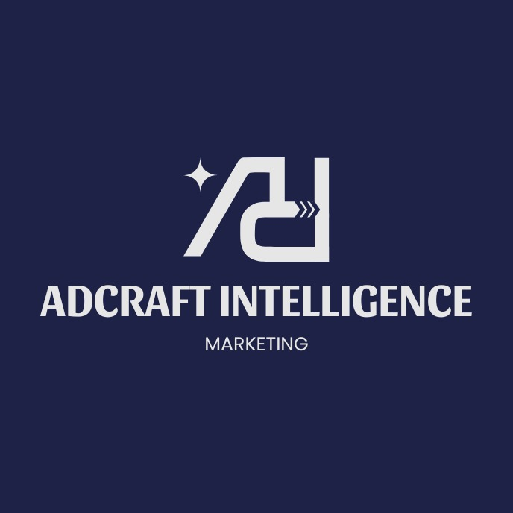
The marketing industry especially the digital marketing sector is predicted to reach the market value of approximately $1.5 trillion by 2030 (Yahoo Finance).

the retail and consumer goods segment holds the largest market share of about 25%. The retail and consumer goods segment is dominating due to the high public awareness about the ads, because of a rapid shift to e-commerce and digital platforms for retail and consumer goods. (marknteladvisors.com, research report)

The Ai generated ads company named “AdCraft Intelligence” is a ‘Subscription + Service Based Model’ which is also disruptive due to low cost on labour, meaning higher efficiency and high scalability.

Generation of this idea (how we got here):
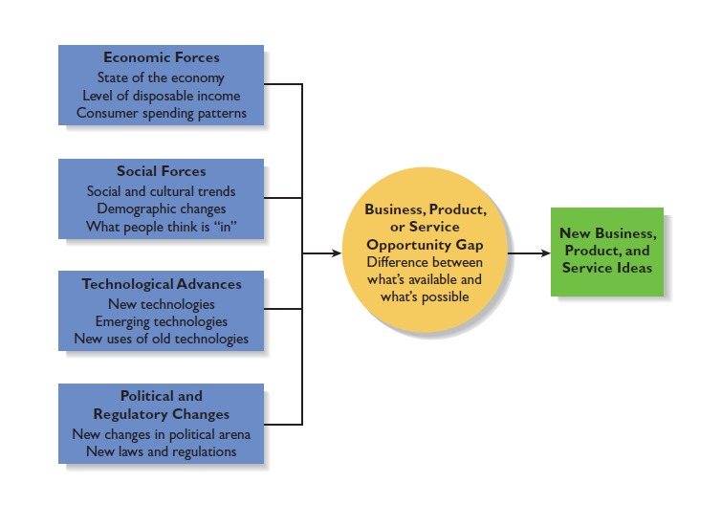
1. Economic Forces
- Cost Efficiency: Businesses are facing tightening budgets and cannot afford expensive traditional ad agencies. Our model captures this market by offering the "lower cost to make ads" that clients desperately need.
- Shift in Spending: Companies are shifting money from "brand awareness" to "performance marketing" where ROI matters most. Our low production costs ensure a significantly higher ROI for them.
- Disposable Income: Small businesses and startups (our target market) have limited capital; we provide them with professional results at a fraction of the standard price.
2. Social Forces
- Content Velocity: "What is in" right now is high-volume content. Social media algorithms (TikTok, Reels) demand fresh creative assets daily. Humans can't keep up; our AI infrastructure can.
- Visual Standards: The public's standard for visual quality is high. Because we deliver "better output from AI," we satisfy the social demand for high-quality aesthetics without the long wait times.
- Trend Adoption: There is a growing cultural acceptance of AI-assisted art and text, making clients more willing to trust the "newer techniques" we are using.
3. Technological Advances
- Emerging Technologies: Generative AI (LLMs and image diffusion models) has matured enough to produce commercial-grade work. This is the foundation of the "newer technique" we are leveraging.
- New Uses of Old Tech: Moving from simple templates (Canva) to fully generative creation (Midjourney/Runway) allows us to offer hyper-personalization that wasn't possible before.
- Better Output: The technology now allows for "better output" that rivals human designers, allowing us to automate what used to be manual labor.
4. Political and Regulatory Changes
- Privacy Regulations: New laws (GDPR) and changes (Apple’s iOS updates) make ad targeting harder. This means the creative (the ad itself) is now the most important lever for success. Our business solves this by generating better creatives faster than the competition.
- Middle Circle: Business, Product, or Service Opportunity Gap
- The Gap: There is a massive difference between "what's available" (expensive, slow human agencies or low-quality DIY templates) and "what's possible" (our instant, high-quality, cost-effective AI ads).
- Market State: As we identified, there is "low market saturation" in this specific niche of high-quality, service-based AI ad generation. The gap is wide open for us to enter as a first mover.
- Green Box: New Business, Product, and Service Ideas
- Our Solution: An AI-First Ad Agency that delivers high-performance creative assets at 1/10th the cost and 10x the speed of traditional firms.
Business model Template
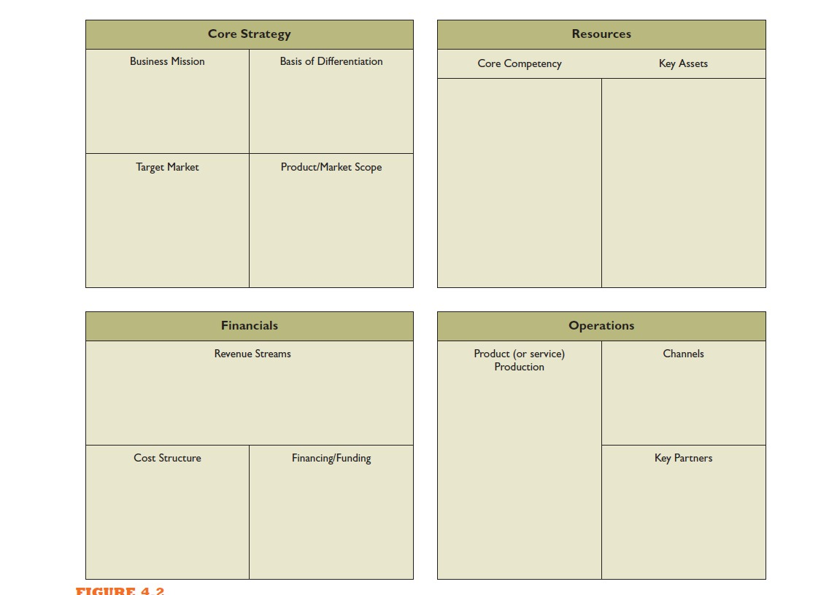
Core Strategy

Business Mission
Build an AI-powered advertising agency that helps businesses generate high-quality social media ads instantly, improving their reach, consistency, and ROI while reducing creative costs and time.

Basis of Differentiation
AdCraft Intelligence stands out by combining automated ad generation with data-driven optimization. The platform offers full creative packages (copy, visuals, targeting insights) tailored to each platform. Continuous learning from ad performance gives clients an adaptive system, not a static tool.

Resources

Core Competency
Expertise in AI model design, automated ad workflows, predictive analytics, and converting brand guidelines into ready-to-run ads for social media platforms.

Key Assets
• Proprietary ad-generation models
• Performance analytics engine
• Brand library system (brand voice, visual style, content templates)
• Technical expertise of the three founding partners
• Early adopter client network

Target Market
Small and medium businesses, digital agencies, e-commerce brands, and solo marketers who need fast, affordable, consistent ad creatives.

Product/Market Scope
Start with AI-generated ads for social media platforms like Facebook, Instagram, TikTok, and LinkedIn. Expand into automated ad campaigns, creative insights dashboards, A/B testing automation, and multi-channel marketing workflows.

Financials

Revenue Streams
• Subscription plans (monthly/annual) based on ad credits
• Agency-tier plans for high-volume creative teams
• Pay-per-campaign premium packs
• Custom integrations for enterprise clients

Cost Structure
• Cloud compute for AI model inference
• Ongoing model training and data acquisition
• Product development and maintenance
• Marketing and sales
• Customer support
• Legal and partnership structure costs

Financing/Funding
Initially bootstrapped by the three partners. Future financing through angel investors once MVP traction is demonstrated, followed by potential seed funding for scale.

Operations

Product (or Service) Production
Ads are generated through a cloud-based AI pipeline: brand inputs → AI creative engine → quality checks → delivery to the user dashboard. Updates and improvements roll out continuously.

Channels
• Web application (primary)
• API access for agencies
• Integrations with social media ad managers (Facebook Ads Manager, TikTok Ads, LinkedIn)
• Website SEO and content marketing
• Direct outreach to agencies and SMBs

Key Partners
• Cloud providers for compute (AWS, GCP, or Azure)
• Social media platforms for ad placement integrations
• Branding and design consultants for template refinement
• Early adopter businesses for feedback loops
• Legal and finance partners for partnership compliance and growth planning
Attractiveness of the industry:
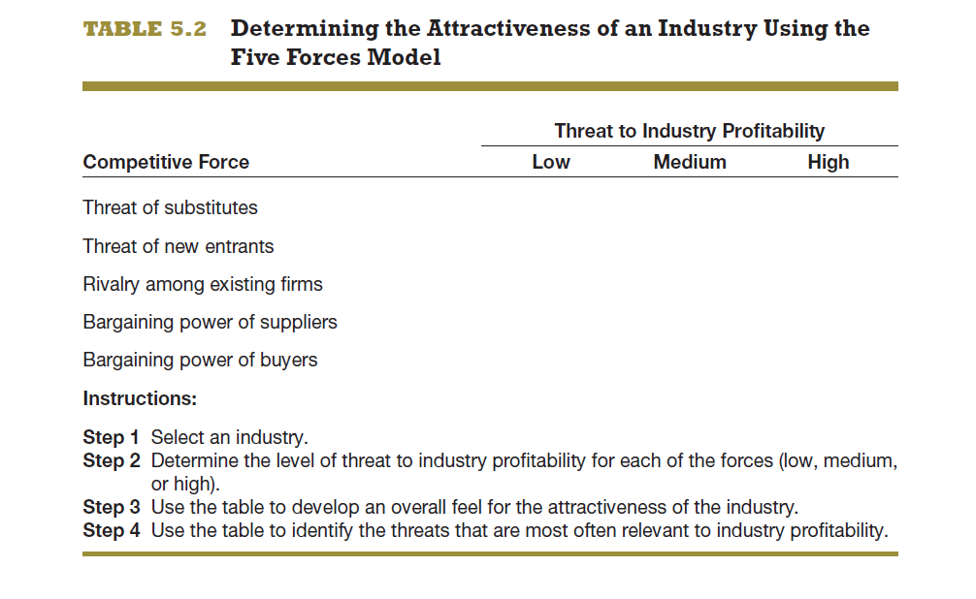
Competitive Force | Low | Medium | High | Notes
Threat of substitutes |  | ✓ |  | Traditional agencies, freelancers, in-house designers, and DIY tools are substitutes, but none offer the speed and automation of AI-first platforms.
Threat of new entrants |  |  | ✓ | Entry barriers are moderate. Anyone with access to AI models and capital can enter. The market is growing fast, so many startups jump in. (like Claybird, Uplane funded by Ycombinator)
Rivalry among existing firms |  |  | ✓ | Competition is intense: Canva, AdCreative.ai, Jasper, Predis.ai, and emerging AI tools all targeting similar segments. Differentiation is essential.
Bargaining power of suppliers | ✓ |  |  | Your main suppliers are cloud compute providers and API services. They are abundant and replaceable, so they hold limited power.
Bargaining power of buyers |  | ✓ |  | SMBs and agencies compare prices easily, but switching costs are moderate because once they store brand data and templates with you, they tend to stay.

This industry is both Emerging and Fragmented, with Global characteristics.
Emerging
AI-generated advertising is still in its early growth phase. Tools like AdCreative.ai, Jasper, and Canva’s AI modules are popular, but the space isn’t fully defined.
Fragmented
No single company controls more than a small slice of the AI ad-gen space.
Global
Any digital marketing tool today automatically enters a global market. Clients come from every region, ads run on global social media platforms, and competitors are international.

Direct Competitors
These are companies doing almost exactly what you’re planning: AI-generated ad creatives (copy + visuals) for social media. (Canva, Jasper.ai)
Indirect Competitors
These don’t generate ads automatically but solve similar problems: creating, managing, or optimizing ads.
Examples: Social Media Management Tools
• Buffer
• Hootsuite
• SocialBee
• Later
Future Competitors
These are players who aren’t fully in your space yet, but can enter easily because of their size, AI resources.
- Large AI Model Providers
• OpenAI (with image + text generation capabilities)
• Google (Gemini + creative studio integrations)
• Meta (LLaMA + AI ad tools inside Business Manager)
• Adobe (Firefly + generative ad templates soon)
One product update from them could shift the landscape.
- Ad Platforms Themselves
These are the biggest threat long-term.
• Meta Ads Manager (already rolling out AI-automated ad creatives)
• Google Ads (Performance Max uses AI heavily)

Summary Business Plan
AdCraft Intelligence
Business Legal form: Partnership (3 partners)
Founders: Arham Hussain (CEO), Aarib Ahmed(CFO), Zaeem ul Haq (COO)
Contact: contact@adcraft.ai
Date: 07th, December 2025
Table of contents (summary)
- Executive summary
- Industry analysis
- Company description
- Market analysis
- The economics of the business
- Marketing plan
- Product design & development plan
- Operations plan
- Management team & company structure
- Overall schedule / milestones
- Financial projections (summary)
- Appendix (assumptions, sample contracts, technical stack, IP notes)

Executive summary (one page)
AdCraft Intelligence provides AI-generated social-media ad creative (copy, static visuals, short-form videos, targeting suggestions) on a subscription + service basis. We deliver platform access for SMBs and agencies plus white-glove services for enterprise clients. Initial traction focus: e-commerce and performance marketing agencies.
Value proposition: reduce creative turnaround from days to minutes, lower creative cost per conversion, and continuously optimize creatives using performance-feedback loop.
Business model: SaaS subscriptions (tiered by credits/creatives), agency/enterprise plans, and custom creative services/integration fees. Founding team: 3 technical/cofounder partners (product, ML/engineering, GTM/sales). Goal: MVP → pilot customers (3–6 agencies) in months 1–6; 1,000 paid SMB users and two enterprise integrations by month 24.
Key asks (if presenting to investors): $400k seed to build core platform, cover 12–18 months of ops, acquire pilots, and scale ML inference and creative ops.

Industry Analysis
Selected industry: AI-driven digital advertising and marketing automation.
Summary view:
- Stage: Emerging and rapidly evolving.
- Structure: Fragmented with many niche players, opportunity for consolidation and differentiation.
- Growth drivers: rising digital ad spend, demand for rapid, high-volume creative, and platform-native ad formats (short video, carousels).
- Key risks: platform-native features from large players, rapid entrant flow, regulatory shifts in data/creative usage.
(For business-plan structure and what to include in industry analysis see Barringer & Ireland). Scribd

Company Description
Mission: Enable brands and agencies to produce higher-performing social ads at scale through automated creative generation and analytics.
Legal structure: Partnership (3 partners). Governance: founder agreement covering equity split, vesting, decision thresholds, capital contributions, profit distribution, and exit terms.
Location & facilities: Remote-first with a small ops HQ (optional). Primary infrastructure: cloud-hosted services for model inference, storage, and analytics.
Key milestones:
- MVP (ad generator + dashboard) — month 3
- Pilot with 3 agencies — month 6
- Public beta + first paid plans — month 9
- Enterprise API/integrations — month 15

Market Analysis
Target segments (initial to expansion):
- SMB e-commerce brands (high need, price sensitive)
- Digital marketing agencies (volume buyers; channel to many end clients)
- Mid-market retailers & DTC brands (enterprise features, integrations)
Buying behavior and drivers:
- Need fast iteration, measurable ROI, A/B-ready creatives.
- High sensitivity to cost-per-acquisition improvements and time-to-market.
- Preference for integrations with ad managers (Facebook/Meta, TikTok, Google) and analytics stacks.
Go-to-market priorities:
- Start with inbound content/SEO + case studies from pilots.
- Channel partnerships with agencies & ad ops consultants.
- Freemium or low-cost trial to reduce trial friction.

The economics of the business
Business model summary:
- Recurring revenue (monthly/annual subscriptions) with usage tiers (credits per creative).
- Professional services (setup, brand templating, creative packs).
- Enterprise integrations and custom models (higher ARPU).
Unit economics metrics to track:
- Customer Acquisition Cost (CAC)
- Monthly Recurring Revenue (MRR) & ARR
- Churn rate (monthly)
- Average Revenue Per Account (ARPA)
- Lifetime Value (LTV = ARPA / churn)
- Gross margin (expect high gross margins on software; lower initially due to compute and model costs)
Cost drivers:
- Cloud compute for inference and training
- Data labeling and creative ops for curated templates
- Engineering and product development
- Sales and marketing (initially founder-led)
Profitability pathway:
- Achieve payback on CAC within 9–12 months by upsells and low churn.
- Improve gross margin via model optimization (lower inference cost) and higher-value enterprise contracts.

Marketing Plan
Positioning: Enterprise-capable, performance-first AI ad generator that tightly couples creative with measurable ad metrics.
Key messages:
- Faster creative production.
- Data-driven creative that learns from performance.
- Easy platform and API integrations for ad operations.
Channels & tactics:
- Content marketing: case studies, how-to for ad ops, ROI examples.
- Partnerships: agency reseller program and platform integrations.
- Paid acquisition: targeted ads to marketing managers and agency owners.
- Product-led growth: free trial and credits; templates for high-conversion verticals.
- PR & thought leadership: publish performance studies, webinars, and workshops.
KPIs:
- Trial-to-paid conversion rate
- Customer Acquisition Cost by channel
- Churn and NPS
- Number of creatives generated per account
Pricing (example tiering):
- Starter: $29/mo — X credits, basic templates
- Growth: $199/mo — higher credits, analytics, A/B testing
- Agency: $799/mo — team seats, client sub-accounts, API access
- Enterprise: custom pricing — SSO, SLAs, on-prem options if required

Product Design and Development Plan
MVP scope (months 0–3):
- Web app: onboarding, brand profile, template library
- AI creative engine: text + image generator producing platform-formatted creatives
- Dashboard: performance metrics & download/export features
- Basic integration: export to Facebook/TikTok ad formats (manual upload or CSV)
Phase 2 (months 4–9):
- Automated campaign bundles (copy + creatives + suggested targeting)
- A/B test automation and creative winner promotion
- Billing / subscription system and agency sub-accounts
Phase 3 (months 10–18):
- Enterprise API, SSO, advanced analytics, historical optimization models
- Short-form video generator and dynamic creative optimization (DCO)
Technology stack (suggested):
- Backend: Node.js / Python microservices
- ML: PyTorch/TensorFlow + HuggingFace models / fine-tuned diffusion models for images; integration with large multimodal APIs as needed
- Cloud: AWS/GCP/Azure for inference and storage
- Frontend: React + Tailwind or component library
IP & data:
- Build proprietary templates and performance datasets.
- Clarify rights for generated creatives in TOS to avoid reuse conflicts.
Quality & safety:
- Synthetic content checks (brand-safety, copyright filters) and human-in-the-loop QA for enterprise packs.

Operations Plan
Daily ops:
- Maintain platform uptime and model inference latency SLAs.
- Customer success for onboarding and creative reviews.
- Continuous training pipeline for models using anonymized performance data.
Facilities & equipment:
- Minimal physical footprint; remote team.
- Cloud infrastructure budgets for inference, storage, and backups.
Key partners (operational):
- Cloud provider (AWS/GCP/Azure)
- Payment processor (Stripe)
- Ad platform integration partners / resellers
- Legal & compliance advisors (IP, data privacy)
Customer support model:
- Self-serve docs + ticketing (Tier 1)
- Dedicated CSM for agency/enterprise clients

Management Team and Company Structure
Founders: 3 partners (roles example)
- Founder 1: CEO / GTM (sales, partnerships, operations)
- Founder 2: CTO / ML lead (product architecture, model development)
- Founder 3: Head of Product / Design (UX, templates, creative ops)
Org plan (first 18 months):
- 0–6 months: Founders + 1 full-stack dev + 1 ML engineer (contract) + freelance designer
- 6–12 months: Add growth lead, customer success rep, SRE/DevOps part-time
- 12–24 months: Expand ML team, sales AE, account manager for enterprise
Advisors: marketing veteran, legal counsel, one ML researcher (part-time).
Governance: partnership agreement with decision rules; prepare for conversion to LLC or Pvt Ltd after seed round.

Overall Schedule (milestones summary)
Month 0–3: Build MVP; onboard 3 pilot customers
Month 4–6: Public beta; iterate; measure performance wins; first paid customers
Month 7–12: Product-market fit push; build agency program; stabilize metrics (CAC, churn)
Month 12–18: Launch enterprise offering + API; ramp sales hiring
Month 18–36: Scale, expand into vertical-specific templates, internationalization, explore Series A

Financial Projections (summary & assumptions)
Slide 1: Competitor Analysis (The "Why Us?" Argument)
* Option A: The "Do It Yourself" Route (Client buys tools)
* Tools Needed: Jasper AI ($49/mo) + Midjourney ($30/mo) + Canva Pro ($13/mo).
* Total Monthly Cost: ~$92 USD (approx. 26,000 PKR).
* Hidden Cost: The client must spend 10+ hours learning prompting and design.
* Result: High cost + High effort.
* Option B: The Traditional Agency
* Service: Human graphic designers and copywriters.
* Total Monthly Cost: $1,000+ USD (approx. 280,000 PKR).
* Hidden Cost: Slow turnaround time (3-5 days for revisions).
* Result: Very high cost + Low effort.
* Option C: Your AI Agency (Our Solution)
* Service: "Done-for-you" AI Ads.
* Total Monthly Cost: 15,000 PKR (Tester Package).
* Benefit: Cheaper than buying the tools themselves and zero effort for them.
* Result: Lowest cost + Zero effort.

Slide 2: Monthly Operational Costs (Revised Lean Model)
* AI Tech Stack: ChatGPT Plus (Rs. 5,600) + Midjourney Standard (Rs. 8,400).
* Note: We removed Canva Pro paid account (using Free version initially) or shared team accounts to cut costs.
* Estimated Cost: 14,000 PKR
* Client Acquisition: Organic LinkedIn/Cold Email (Manual outreach, no paid ads).
* Estimated Cost: 0 PKR (Time-based investment only)
* Utilities & Internet: Removed (Assumed covered by household/personal budget).
* Estimated Cost: 0 PKR
* Miscellaneous: Hosting/Domain (Basic).
* Estimated Cost: 1,000 PKR
* TOTAL MONTHLY COST (Burn Rate): 15,000 PKR
(Note: We slashed costs by 64% by removing utilities and paid ads, making the business break-even with just one client.)

Slide 3: Pricing Strategy (Revenue Model)
* 1. The "Tester" Package (Local/Small Biz)
* Deliverable: 5 Static AI Ad Creatives + 2 Variations.
* Price: 15,000 PKR ($50).
* Competitive Edge: This is cheaper than the client buying a Jasper AI subscription ($49).
* Target: 3 clients/month.
* 2. The "Growth" Retainer (International/Agency White-label)
* Deliverable: 20 Ad Creatives/month + Weekly Refresh.
* Price: 85,000 PKR ($300).
* Competitive Edge: Traditional agencies charge $2,000+ for this volume.
* Target: 1 client/month.
Slide 4: 6-Month Financial Projection (Optimized)
* Month 1 (Investment Phase):
* Clients Won: 1 (Tester)
* Total Revenue: 15,000 PKR
* Total Expenses: 15,000 PKR
* Net Profit: 0 PKR (Break-even immediately)
* Month 2 (Profitability):
* Clients Won: 2 (Tester)
* Total Revenue: 30,000 PKR
* Total Expenses: 15,000 PKR
* Net Profit: +15,000 PKR
* Month 3 (Growth):
* Clients Won: 3 (Tester) + 1 (Growth)
* Total Revenue: 130,000 PKR
* Total Expenses: 18,000 PKR*
* Net Profit: +112,000 PKR
* Month 4 (Scaling):
* Clients Won: 4 (Tester) + 1 (Growth)
* Total Revenue: 145,000 PKR
* Total Expenses: 18,000 PKR
* Net Profit: +127,000 PKR
* Month 5 (High Growth):
* Clients Won: 3 (Tester) + 2 (Growth)
* Total Revenue: 215,000 PKR
* Total Expenses: 20,000 PKR**
* Net Profit: +195,000 PKR
* Month 6 (Stable Income):
* Clients Won: Stabilized Retainers
* Total Revenue: 250,000 PKR
* Total Expenses: 20,000 PKR
* Net Profit: +230,000 PKR
*Expenses increase slightly for better file storage/hosting as clients grow.
**Expenses increase to pay for premium automation tools once cash flow is high.

Appendix (what to include)
- Sample pilot case study and performance before/after
- Sample ad video
Founder’s Agreement:
